

**2025 MAEA Secondary Art Educator of the Year**

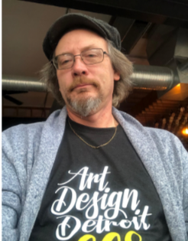**Keith Rayner** was born in Mt. Clemens and attended L’Anse Creuse Public Schools learning from the sculpture teacher, Tony Bellmo. He attended Valparaiso University where he received a Bachelor’s of Art in Art with a concentration in photography and sculpture and a minor in mathematics. There he worked with George Strimbu in photography and Richard Brauer in museum studies and sculpture. After graduation, he went on to pick up a teaching degree in the areas of art, math, and special education. Keith attended Saginaw Valley State University for a Master of Education degree.

Keith has been a teacher for thirty years. Teaching special education and art in a couple different districts before being hired in the Lakeview District. Keith has been a member of the Michigan Art Education Association for twenty plus years, volunteering as a Region 6 liaison and co-chair of the Secondary Division. These jobs allowed him to work with many great teachers in the greater Detroit area and throughout the state and volunteering to work on many art shows, promoting the art students’ work in many art shows including Scholastics, Anton, Wayne State and MAEA Top 100 and Governors’ Show. He has assembled slideshows for the region's Scholastic Show for the past twenty years that teachers can use in the classroom. The past five years Keith has adjudicated many shows including the St. Clair Shores Palette Club Shows and an art show for Anton Art Center.

Some of his past art shows include The Teacher Show at the Anton Center this past summer with an Honorable Mention for a cyanotype photograph. He has had work accepted in the Michigan Art Education Association/Michigan Education Association Art Acquisitions Exhibition for the past 18 years with different honors. His work has also been featured in the Michigan Annual. The media that he currently works in varies with the type of classes he is teaching. His mediums include photography, 3-D art, sculpture/ceramics, graphic design and fibers. He has been making handmade paper from plants and recycled materials and is currently working on bookbinding, weavings, and alternative digital photography processes.